## **Growing And Shrinking**

Let’s look a little closer at what actually happened when you put flex: 1 on those flex items in the last lesson.

### **Learning Outcomes**

* You’ll learn the 3 properties that are defined by the flex shorthand, and how to use them individually.

### **The flex shorthand**

The flex declaration is actually a shorthand for 3 properties that you can set on a flex item. These properties affect how flex items size themselves within their container. You’ve seen some shorthand properties before, but we haven’t officially defined them yet.

Shorthand properties are CSS properties that let you set the values of multiple other CSS properties simultaneously. Using a shorthand property, you can write more concise (and often more readable) stylesheets, saving time and energy.

Source: [Shorthand properties on MDN](https://developer.mozilla.org/en-US/docs/Web/CSS/Shorthand_properties)

In this case, flex is actually a shorthand for flex-grow, flex-shrink and flex-basis.

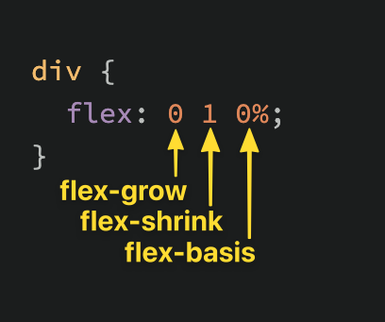

The default value of the flex property is shown in the above screenshot: flex-grow: 0, flex-shrink: 1, flex-basis: 0%. Very often you see the flex shorthand defined with only *one* value. In that case, that value is applied to flex-grow, so when we put flex: 1 on our divs, we were actually specifying flex: 1 1 0%.

### **flex-grow**

flex-grow expects a single number as its value, and that number is used as the flex-item’s “growth factor”. When we applied flex: 1 to every div inside our container, we were telling every div to grow the same amount. The result of this is that every div ends up the exact same size. If we instead add flex: 2 to just one of the divs, then that div would grow to 2x the size of the others.

In the following example the flex shorthand has values for flex-shrink and flex-basis specified with their default values.

<https://codepen.io/TheOdinProjectExamples/pen/YzQqvgK>

### **flex-shrink**

flex-shrink is similar to flex-grow, but sets the “shrink factor” of a flex item. flex-shrink only ends up being applied if the size of all flex items is larger than their parent container. For example, if our 3 divs from above had a width declaration like: width: 100px, and .flex-container was smaller than 300px, our divs would have to shrink to fit.

The default shrink factor is flex-shrink: 1, which means all items will shrink evenly. If you do *not* want an item to shrink then you can specify flex-shrink: 0;. You can also specify higher numbers to make certain items shrink at a higher rate than normal.

Here’s an example. Note that we’ve also changed the flex-basis for reasons that will be explained shortly. If you shrink your browser window you’ll notice that .two never gets smaller than the given width of 250px, even though the flex-grow rule would otherwise specify that each element should be equally sized.

<https://codepen.io/TheOdinProjectExamples/pen/JjJXZVz>

An important implication to notice here is that when you specify flex-grow or flex-shrink, flex items do not necessarily respect your given values for width. In the above example, all 3 divs are given a width of 250px, but when their parent is big enough, they grow to fill it. Likewise, when the parent is too small, the default behavior is for them to shrink to fit. This is not a bug, but it could be confusing behavior if you aren’t expecting it.

### **flex-basis**

flex-basis simply sets the initial size of a flex item, so any sort of flex-growing or flex-shrinking starts from that baseline size. The shorthand value defaults to flex-basis: 0%. The reason we had to change it to auto in the flex-shrink example is that with the basis set to 0, those items would ignore the item’s width, and everything would shrink evenly. Using auto as a flex-basis tells the item to check for a width declaration (width: 250px).

#### **Important note about flex-basis:**

There is a difference between the default value of flex-basis and the way the flex shorthand defines it if no flex-basis is given. The actual default value for flex-basis is auto, but when you specify flex: 1 on an element, it interprets that as flex: 1 1 0. If you want to *only* adjust an item’s flex-grow you can simply do so directly, without the shorthand, or you can be more verbose and use the full 3 value shorthand flex: 1 1 auto

### **In practice…**

In practice you will likely not be using complex values for flex-grow, flex-shrink or flex-basis. Generally, you’re most likely to use declarations like flex: 1; to make divs grow evenly and flex-shrink: 0 to keep certain divs from shrinking.

It *is* possible to get fancy, and set up layouts where some columns relate to each other in a specific ratio, so it’s useful to know that you can use other values, but those are relatively rare.

### **Knowledge Check**

This section contains questions for you to check your understanding of this lesson. If you’re having trouble answering the questions below on your own, review the material above to find the answer.

* What are the 3 values defined in the shorthand flex property (e.g. flex: 1 1 auto)?